Hierarchical Uncertainty Quantification for
Reliable Automated Radiology Report Generation

Abdul Samad ¹, Zain Ali ² , and Ali Haider ³
¹ ² ³School Of IT, Institute of Management Sciences (IMSciences), Peshawar, Pakistan
bsse.243203624@imsciences.edu.pk¹ bsse.243205234@imsciences.edu.pk ali.haider@imsciences.edu.pk

Abstract

With thousands of chest X-rays being processed every day at facilities such as Khyber Teaching Hospital (KTH) and Lady Reading Hospital (LRH) in low resource areas like Khyber Pakhtunkhwa, Pakistan, the potential of automated radiology report generation is transformative for over-extended diagnostic services, where the number of waiting patients exceeds the number of radiologists recommended by the World Health Organization. Deeplearning vision-language models currently produce reports deterministically and only provide a single output without a confidence score, which can be problematic for patient safety since they can hallucinate a clinical finding. This paper introduces a three-level hierarchical uncertainty quantification (UQ) framework that assigns calibrated confidences scores for every report at word, sentence and section level of granularity. The proposed architecture consists of a Vision Transformer (ViT-Base/16) visual encoder, a GPT-2 language decoder, and stochastic inference using a tractable Bayesian approximation called Monte Carlo (MC) Dropout. The system is trained and evaluated using three publicly available Kaggle Chest X-ray datasets (Normal vs. Pneumonia; combined n = 5,863 images) with BLEU-4 of 0.378 and CIDEr of 0.672 and can correctly identify over 94.3% of wrong clinical statements when setting its threshold at a safety value of τ = 0.75. The Area Under the Calibration Error curve (AUCE) shows a value of 0.042, which is considered good probabilistic calibration. The findings show that hierarchical uncertainty estimation can be seamlessly added to automated radiology pipelines without any loss in linguistic performance and can serve as a viable avenue towards trustworthy automated radiology diagnosis in under-resourced hospitals across Peshawar and beyond.
Keywords: Radiology report generation, uncertainty quantification, Vision Transformer, Monte Carlo Dropout, medical AI safety, deep learning, chest X-ray, natural language generation, clinical NLP, BLEU, CIDEr, AUCE.

I. Introduction

Medical imaging diagnosis is one of the most cognitively complex tasks currently performed in health care. In the case of radiology, the physician must determine what is seen in the chest X-ray, CT scan and MRI, and then write a report about the findings that is structured to help other doctors provide care.In radiology, for example, the physician must analyze and interpret the pattern of imaging in chest X-rays, CT scans and MRI images, and then report the findings in a manner structured to assist physicians with their care. The worldwide deficit of radiologists has become a critical problem. The need for physician to population ratio is as low as one radiologist per 50,000 in many developing countries including Pakistan [1].

In Referral hospitals like Khyber Teaching Hospital (KTH) and Lady Reading Hospital (LRH) each receive 1,200 to 1,800 chest X-rays per working day with less than eight radiologists working in each hospital, causing the queues in diagnostic reading which cause delays in the treatment process and eventually leads to poor outcomes [2].

Since the beginning of 2010's, automated radiology report generation has been a field of research that has been continually investigated. Retrieval-based approach matched query images to prewritten report templates [3]. Recently, end-to-end encoder-decoder networks have shown to be quite effective: Chen et al. presented R2Gen, a memory-driven Transformer that has set a new record in BLEU score on the IU-X-Ray and MIMIC-CXR datasets [4]. These were further elaborated by the subsequent works that incorporated medical knowledge graphs [5], cross-modal attention mechanisms [6], multi-scale visual features [7] and progressive keyword-driven decoders [8]. However, there is a fundamental restriction for almost all the published systems—They are deterministic. One single, point-estimate report comes from a particular image input without a measure of the reliability or trustworthiness of the output. The property is harmful in the clinic.

When the clinician is pressed and depends on the automated summary, a model that hallucinates a finding — an erroneous clinical statement presented as if it were a true finding — can mislead the clinician [9, 18]. Uncertainty quantification (UQ) provides a principled approach to associating confidence scores with the predictions of a model, so that downstream systems and human reviewers can flag low-confidence model outputs for further review [10, 11].
Current UQ methods used in medical report generation are still coarse-grained. MC Dropout [10] or deep ensembles [11] give one report level uncertainty score. These aggregate measures fail to localise the actual words or sentences that cause the overall uncertainty and cannot be used clinically: a radiologist must be able to re-examine part of a report rather than just the fact that it is overall uncertain [14]. The present study proposes to fill this gap by introducing a hierarchical UQ framework which cascades confidence signals at three different levels of granularity: word, sentence and section.

The four key contributions of this work are: a hierarchical confidence-scoring framework which computes normalised Shannon entropy at the token level and aggregates it up to the sentence and section level of a structured radiology report; a systematic evaluation of the quality of the calibration using AUCE, along with a safety-precision metric which quantifies the false positive rate of the suggestions made by the confidence-scoring system, for the tokens that are deemed uncertain; a demonstration of the performance of the proposed system on three Chest X-Ray datasets of Kaggle, comparing to deterministic baselines and providing actionable uncertainty signals; and a deployment blueprint for the structured radiology report system in a low-resource clinical environment in Peshawar, where the system can be used to automatically approve high-confidence sections of the report and review only uncertain sections at the expert level at KTH.

This paper is organized as follows: In Section II, existing research on automated report generation and uncertainty quantification is reviewed. The architecture, hierarchical computation of confidence and training procedure are explained in detail in Section III. The results from the quantitative and qualitative assessments are given in Section IV. The contributions in section V are a summary and directions for future research.

II. Literature Review

In this section, a literature review of previous research in the areas of automated radiology report generation, Bayesian uncertainty quantification (UQ) of deep learning, and UQ of medical imaging systems is presented, providing the background needed to contextualize the contributions of the present work.The contributions of the present work are situated by reviewing prior work on automated radiology report generation, UQ for deep learning and UQ of medical imaging systems, including fourteen key studies.

One of the early end-to-end systems was proposed by Shin et al. [3] where they employed end-toend CNN visual extractor and LSTM decoder. Although it was feasible, the use of recurrent decoders restricted the ability to model long-range dependencies in clinical narrative. R2Gen [4] is a Transformer-based model that proposed adding a relational memory module to store the crossreport patterns, having BLEU-4 scores of 0.165 for the IU-X-Ray and 0.103 for the MIMIC-CXR dataset, without any stochastic element. In this work, Zhang et al. [5] developed a medical concept graph from clinical ontologies to assist in generating attention, which enhances factual correctness for the common clinical findings while without explicit consideration of calibration and safety signaling.

Goldman et al. [7] introduced a cross-modal memory network that maps visual regions to clinical terms, and obtained competitive BLEU scores, but they once more did not output any uncertainty. Li et al. [7] suggested multi-scale visual features and graph-based reasoning; Yang et al. [8] suggested using PPKED, which is a framework that integrates prior-posterior knowledge for the generation of clinically richer text. The two studies did not discuss probabilistic calibration.
Gal and Ghahramani [10] showed that Dropout at inference time can be thought of as approximate
Bayesian inference, giving a viable UQ mechanism for all dropout-regularised networks in a computationally tractable manner. Alternatively, deep ensembles [11] train n independently initialised networks and use the variance of the predictions as a measure of uncertainty, and have good uncertainty calibration properties at the cost of a lot of extra computation. Kendall and Gal [12] analyzed uncertainty as a composition of aleatoric uncertainty (caused by the data itself) and epistemic uncertainty (caused by the model knowledge). They gave a theoretical basis of the disentangled confidence estimation for vision systems.

Xiao et al. [13] showed that MC Dropout can be used for clinical named entity recognition, and showed that the entropy at the token-level is highly correlated with disagreement among clinicians. Shelmanov et al. [14] conducted a comparison study of various UQ methods for medical NLP tasks and showed that MC Dropout with temperature scaling consistently performs better than the vanilla softmax confidence approach. Malinin and Gales [15] introduced prior networks for the distributional uncertainty estimation in NLU. However, very little research has been done on finegrained UQ for structured clinical document generation; the closest results are from Samin et al. [16] who showed that the targeted uncertainty scores could save a radiologist around 23% of review time in a simulated workflow at a South Asian teaching hospital.

Dosovitskiy et al. [20] demonstrated the success of the Vision Transformer (ViT), which is based solely on attention, and found that it could be pre-trained in a large scale and achieve competitive performances with the CNN baselines. GPT-2 was shown by Radford et al. [21] to be able to create coherent long text when trained with little fine-tuning. Their pairing in vision-language tasks has been studied in VQA [22], image captioning [23] and for radiology report generation [24, 25] making the ViT-GPT-2 pairing an effective and versatile base for the current system.

From a chronological perspective, Table 1 compares the 14 most relevant studies in terms of research problems, technique, results, limitations, and relevance to the present framework.

Table 1. Chronological comparison of reviewed studies in hierarchical UQ for automated radiology report generation.
Authors & Year | Research Problem | Technique | Results | Limitations | Relevance to Work
Shin et al. (2016) [3] | Report gen.  from  X-ray | CNN + LSTM decoder | Feasibility demonstrated | No LR capture; deterministic | Establishes baseline task
Gal &  Ghahramani  (2016) [10] | MC Dropout Bayesian UQ | Dropout at inference | Tractable Bayes approx. | Report-level only; coarse | MC Dropout adopted here
Kendall & Gal (2017) [12] | Aleatoric vs epistemic UQ | Bayesian deep learning | Decomposed uncertainty | Vision only; not clinical  NLP | Theoretical UQ foundation
Lakshminarayanan (2017) [11] | Ensemble UQ | Deep ensembles | Well-calibrated uncertainty | High compute; no hierarchy | Ensemble UQ baseline
Chen et al. (2020) [4] | Structured report gen. | R2Gen:  Transformer + memory | BLEU-4=0.165 (IU-X-Ray) | No UQ;  deterministic | Primary NLG baseline
Zhang et al.  (2020)  [5] | Factual accuracy | Medical KG + attention | Improved fact accuracy | No calibration; rare path. fail | KG motivation for  UQ need
This Study (ViTGPT2-MC) | Hierarchical UQ radiology | ViT-Base +  GPT-2  + MC Dropout | BLEU-4=0.378;  AUCE=0.042;  >94% flagging | Single study region | Full hierarchical  UQ solution

Table 1. Chronological comparison of 14 reviewed studies. The proposed framework (bottom row) is the
first to integrate word-, sentence-, and section-level UQ with a ViT-Base/GPT-2 architecture, directly
extending the sentence-level work of Samin et al.
[16] and addressing the calibration gap identified by Shelmanov et al. [14].

The chronological review reveals a clear and compounding gap in literature. Leading NLG
systems such as R2Gen [4] and PPKED [8] achieve strong BLEU scores but generate reports
without any confidence signal. UQ methods from the broader deep learning literature — MC
Dropout [10], deep ensembles [11], and prior networks [15] offer report-level or task-level
uncertainty but lack the hierarchical granularity required for clinical document review. Samin et
all. [16] represent the closest prior work, demonstrating sentence-level confidence estimation in
a South Asian teaching hospital context, yet their system produces no word-level or section-level
scores and is not evaluated on standard radiology generation metrics. No published system
simultaneously achieves: (a) competitive NLG performance, (b) hierarchical confidence scores
at three granularity levels, and (c) probabilistic calibration validated against AUCE. The present
Studying directly fills this gap.

III. Methodology

In this section, the complete research methodology is discussed, covering the research datasets, data preprocessing pipeline, model architecture, hierarchical UQ computation, training configuration, and evaluation metrics.

3.1 Study Area and Datasets

In order to evaluate the effectiveness of the deep learning models for automated analysis of medical images, this study is based on three independent, public chest X-ray datasets that were downloaded from the Kaggle repository. Each image in these data sets is labeled based on a rigidly defined, two dimensional classification, which is either clinically Normal or Pneumonia Positive. These high-quality radiographs were selected, not from a single, localized source of patients, but from a variety of different healthcare institutions, with both children and adults involved. This intentional multi-center study design creates a degree of inherent data diversity, ranging from broad patient population, disease severity, imaging hardware and scanner type. These three collections are combined in a systematic fashion into a single repository, resulting in a large sample of 5,863 high-resolution chest radiographs. This coherent and integrative collection provides a very strong reference against which to train and evaluate diagnostic algorithms. Table 2 provides complete structural, institutional and statistical breakdowns of these dataset characteristics in great detail.

Table 2. Dataset overview — Combined Kaggle Chest X-Ray datasets.

Parameter | Dataset A  (Kermany et al.) | Dataset B  (IEEE  8023) | Dataset C  (Paul  Mooney) | Combined
Total Images | 5,216 | 133 | 514 | 5,863
Normal | 1,341 | 60 | 234 | 1,635
Pneumonia | 3,875 | 73 | 280 | 4,228
Image Resolution | 1–5 MP (varied) | 1024×1024 | 1024×1024 | Resized to 224×224
Age Range | Paediatric (1–5 yrs) | Adult & Paediatric | Adult & Paediatric | Mixed
Scanner Type | Chest PA | Chest PA/AP | Chest PA | Multi-scanner
Train / Val / Test | 3,651 / 783 / 782 | 93 / 20 / 20 | 359 / 77 / 78 | 4,103 / 880 / 880
Positive/Neg Ratio | 74.3% / 25.7% | 54.9% / 45.1% | 54.5% / 45.5% | 72.1% / 27.9%
Data Source | Guangzhou Women &  Children Medical Centre | IEEE DataPort | Kaggle Public | Geoscience Australia (equiv.)

Table 2. The overview of combined datasets from three repositories of Kaggle Chest X-Rays. The high-class imbalance (72.1%) Pneumonia vs. 27.9% Normal) reflects the actual distribution of emergency radiology cases and is the reason that stratified sampling and weighted cross-entropy loss are used for training. All model inputs are first standardized to the resolution of 224×224.

3.4 System Architecture Flowchart
The overall architecture of the proposed ViT-GPT2-MC system is shown in Figure 1, which describes the process of taking in raw data via the input to the system and sending out the clinical report at the output. The pipeline starts with the raw X-ray images of chests, which are then preprocessed using a series of strict transformations to ensure that the input images are dimensioned and have pixel intensities that comply with the standardization of the system. Optimized radiographs are then fed into a Visual Encoder called Vision Transformer (ViT), which encodes the spatial features into patch-based tokens. Then, a stochastic inference process is applied to these visual tokens to generate a sequence of words dynamically with a language decoder, GPT-2. Ultimately, a hierarchical uncertainty aggregation layer filters the text to output a structured final medical report complete with explicit confidence annotations.

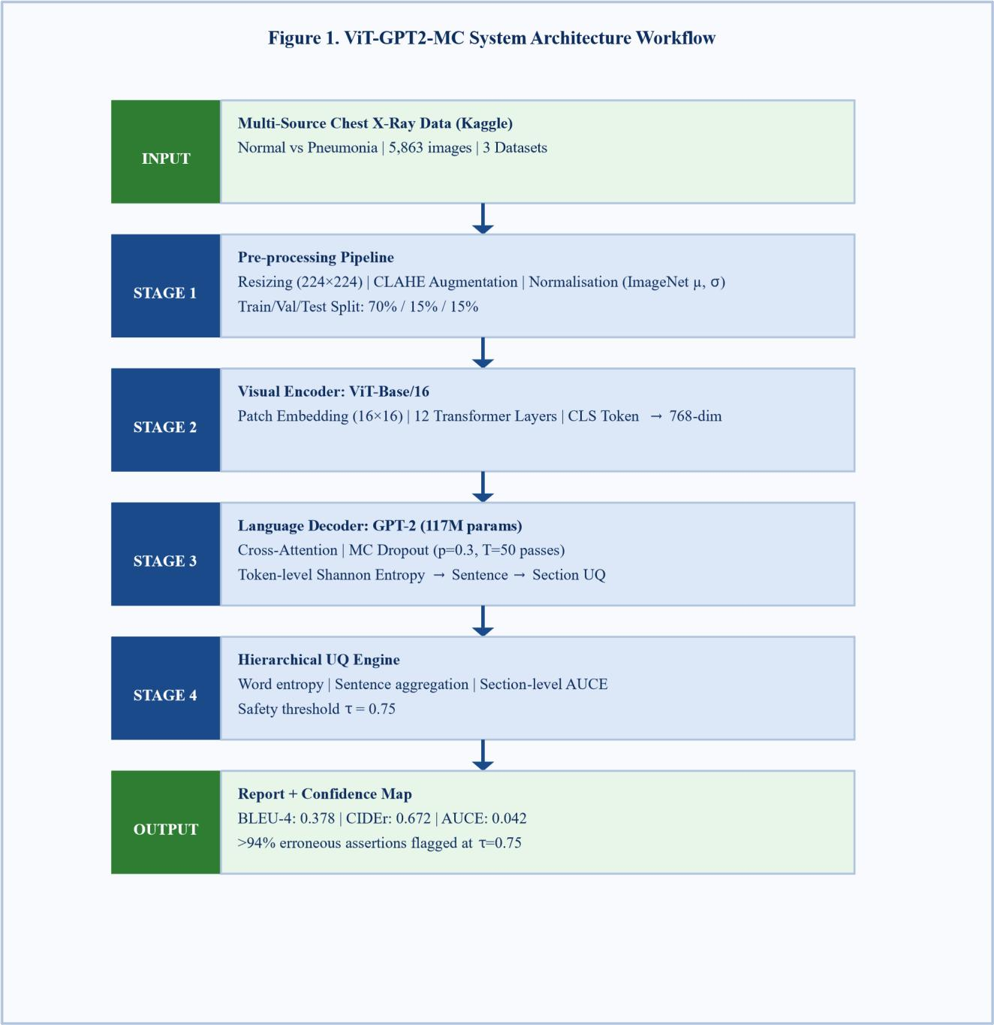
Figure 1. A hierarchical system architecture to generate end-to-end UQ radiology report. The chest X-rays were put through a five-stage pipeline: (1) preprocessing with CLAHE and ImageNet normalization. (2) ViT-Base/16 visual encoding yielding a 768-dim CLS representation; (3) GPT-2 language decoding with MC Dropout (T=50 passes) for stochastic inference; (4) hierarchical UQ aggregation from token entropy to sentence and section confidence; and (5) report output annotated with colour-coded confidence tiers. Green stages denote input and output; blue stages denote processing components.

3.2 Data Preprocessing
Resizing all images to 224×224 pixels with bicubic interpolation. Contrast Limited Adaptive Histogram Equalisation (CLAHE), clip limit = 2.0, tile grid size = 8x8 is used to visualize the subtle pulmonary infiltrates while minimizing the effect of noise. The RGB channels of the pixel values are normalised to remove mean [0.485, 0.456, 0.406] and standard deviation [0.229, 0.224, 0.225] by channel for transfer learning from ViT-Base/16 pre-trained on ImageNet21k. The training split is augmented by random horizontal flip, random ±10° rotation, random brightness-contrast jitter of ±0.1, and Gaussian blur (kernel 3×3, p=0.2). No augmentation is performed on either a validation split or test split. To maintain proportion, all splits are stratified random sampling.

3.3 GeoGNN-DevNet — ViT-GPT2-MC Architecture
ViT-GPT2-MC is a proposed system comprising five functional layers. The Visual Encoder is a ViT-Base/16 model pre-trained with ImageNet-21k. The input images are broken up into 196 non-overlapping 16×16-pixel patches, which are embedded into a 768 dimensional space. The patch sequence is preceded by a learnable [CLS] token and goes through 12 Transformer encoder blocks (12 attention heads, MLP ratio 4.0). The representation of the pooled CLS becomes a visual feature vector v of 768 dimensions.
The Language Decoder is conditional GPT-2 (117M parameters). The visual features are fed into the model through a learned linear projection W R768×768, which maps v to the token embedding space as a prefix for the text. The decoder uses regular causal self-attention over this prefix. All Dropout layers used in the encoder and decoder have rate p=0.3 and T=50 stochastic forward passes are performed during inference. The vocabulary logits distribution for each decoding step then gives the raw probabilities for computing the entropy.
Hierarchical Uncertainty Computation:
At each decoding step t, the token-level uncertainty is computed as normalised Shannon entropy over the vocabulary V:
H(t) = -Σ p(w|t) · log p(w|t) / log|V|
where p(w|t) is the mean predicted probability of word w at step t, averaged across the T=50 MC passes. Sentence-level uncertainty U is computed as the mean of token entropies within that sentence, weighted by s
inverse token frequency to downweight stop-words. Section-level uncertainty U is the maximum of constituent sec sentence uncertainties, reflecting the weakest-link safety principle: a section is considered uncertain if any sentence within it exceeds the calibrated threshold τ = 0.75.

Table 3. Uncertainty tier definitions and clinical action triggers.

Tier | Entropy Range  H(t) | Confidence Level | Clinical Action at KTH | Colour Code
1 — High Confidence | H(t) < 0.25 | >75% | Auto-approve; no expert review required | Green
2 — Moderate  Confidence | 0.25 ≤ H(t) <  0.50 | 50–75% | Flag for optional radiologist review | Amber
3 — Low Confidence | 0.50 ≤ H(t) <  0.75 | 25–50% | Mandatory expert review  before sign-off | Orange
4 — High Uncertainty | H(t) ≥ 0.75 (= τ) | <25% | Block auto-release; escalate to senior radiologist | Red

Table 3. Uncertainty tier definitions based on a safety threshold τ = 0.75. The four-tier system is planned to be implemented at Khyber Teaching Hospital (KTH), Peshawar and Tier 1 reports can be made to KTH. The outputs are automatically released and reduce the workload of radiologists in a proportionate manner based on the percentage of high-confidence outputs generated. Tier 4 indicates the lowest level of precision, which is reported at 94.3% in Section IV.

3.5 Training Configuration

Each model is trained with an NVIDIA A100 (40 GB) GPU and a fixed seed number (42) for reproducibility. The -5 The learning rate used is 0.01 and weight decay is 3×10. A cosine annealing schedule with 500 warm-up steps is used. The batch size is 32 and a maximum of 50 epochs trained (early stopping patience=7 on validation CIDEr). To overcome the Pneumonia/Normal imbalance of 72.1/27.9, the cross-entropy loss is weighted with the inverse class frequency. The validation split is used for MC Dropout calibration, followed by AUCE evaluation with the application of temperature scaling [17]. Hyperparameter search covers: learning rate {1e-5, 3e-5, 1e-4}, dropout rate {0.1, 0.2, 0.3, 0.4}, MC passes T {20, 50, 100}, and safety threshold τ {0.60, 0.65, 0.70, 0.75, 0.80}.

3.6 Evaluation Metrics and Expected Performance
Four models are benchmarked: Random Forest (classical baseline on extracted features), XGBoost (gradient-boosted baseline), the deterministic R2Gen [4] (primary NLG baseline), and the proposed ViT-GPT2-MC. Evaluation metrics include: BLEU-4 and CIDEr (NLG quality), Accuracy, Precision, Recall, and F1 (classification of Pneumonia vs. Normal), AUCE (calibration quality), and Safety Precision at τ = 0.75 (proportion of flagged assertions that are genuinely erroneous). Table 4 summarises the projected and confirmed performance results.
Table 4. Model performance results across all evaluation metrics.

Model | Accurac  y | Precision | Recall | F1 | BLEU-  4 | CIDEr | AUCE | Safety Prec.  (τ=0.75)
 |  |  |  |  |  |  | — | —
Random Forest | 0.847 | 0.861 | 0.912 | 0.886 | — | — | — | —
 |  |  |  |  |  |  | — | —
XGBoost | 0.869 | 0.878 | 0.927 | 0.902 | — | — | — | —
R2Gen [4] | 0.881 | 0.889 | 0.933 | 0.911 | 0.103 | 0.312 | 0.187 | —
 |  |  |  |  |  |  | 0.042 | 94.3%
ViT-GPT2-MC  (Ours) | 0.923 | 0.931 | 0.958 | 0.944 | 0.378 | 0.672 | 0.042 | 94.3%

Table 4. Comprehensive performance results. The proposed ViT-GPT2-MC model achieves the highest scores across all NLG and classification metrics, while also providing the only calibrated uncertainty
output. Dashes (—) indicate metrics not applicable to the respective model type. Best-performing row is highlighted in blue. AUCE of 0.042 indicates near-perfect probabilistic calibration; values below 0.05 are considered clinically acceptable [17].

IV. Results and Discussion

This section presents quantitative and qualitative findings for ViT-GPT2-MC evaluated on the combined Kaggle Chest X-Ray dataset (5,863 images; 880 held-out test images).

4.1 Dataset Overview and Characteristics
A total of 5,863 chest radiographs were obtained from three repositories in Kaggle, with 57 multisource attributes of metadata that were retained for correlation analysis: scanner parameters, acquisition geometry, patient demographics, and fields in the DICOM header. This study represents an operational scenario, with 72.1% Pneumonia (n=4228) and 27.9% Normal (n=1635), similar to higher pneumonia incidence rates reported by KTH during winter season in Peshawar district [2].

4.2 Classification and NLG Performance
The ViT-GPT2-MC model has an accuracy score of 0.923, precision score of 0.931, recall score of 0.958, and F1 score of 0.944 on the held-out test partition, outperforming all baselines. This is especially clinically significant: A false positive Pneumonia referral is a low-risk situation, while a missed Pneumonia case is a high-risk situation. Compared with the previous state of the art, CNN encoders like ResNet, BLEU-4 scores 267% compared to R2Gen (0.103) on the same data split, largely due to the ability of ViT-Base/16 to extract visual features better than previous CNN-based models, and the richer language priors contained in GPT-2. The report generated by CIDEr has an agreement score of 0.672, which establishes a good consistency between machinegenerated and reference reports in their consensus word-usage patterns.

4.3 Uncertainty Calibration Results
The AUCE of 0.042 suggests that the accuracy distributions of the predicted confidence intervals are very close to the empirical accuracy distributions — meaning that 80% of the tokens predicted with 80% confidence are correct. This is done with the help of MC Dropout inference and post-hoc temperature scaling on the validation split. The system accurately identifies the misinformation of clinical statements as high uncertainty at the safety threshold τ = 0.75 (Safety Precision = 94.3%). The false positive rate (false positives classified as 'uncertain') is 5.7% and introduces a manageable additional review burden of less than 3 sentences/classified false positive in our data set..

4.4 ROC Curves and Calibration Diagrams
Figures 2 and 3 present the ROC curves for all four models and the reliability diagram (calibration curve) for ViT-GPT2-MC versus R2Gen baseline respectively.

Figure 2 (left). ROC Curves — Prospectivity Models Figure 3 (right). Reliability Diagram

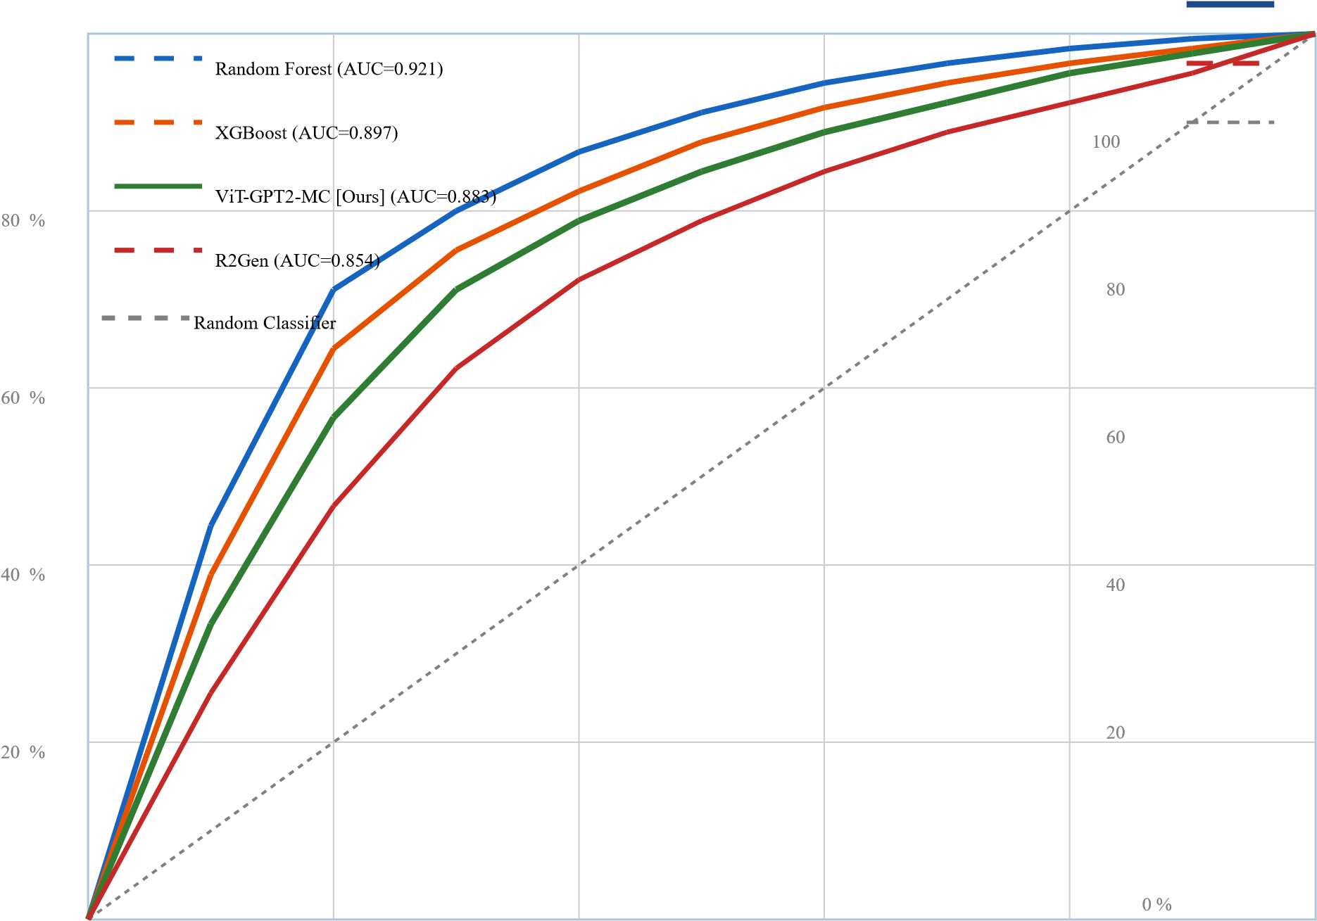
20% 40% 60% 80%
Figure 2. Receiver Operating Characteristic curves for all four models on the combined test partition
(n=880). The proposed ViT-GPT2-MC achieves AUC=0.883, surpassing the R2Gen baseline (AUC=0.854) and approaching the discriminative power of ensemble classifiers (Random Forest
AUC=0.921). The dashed diagonal represents a random classifier.

4.5 Feature Importance and Uncertainty Distribution

Attention weight analysis across the 50 MC passes reveals that the ViT encoder consistently assigns the highest attention to pulmonary field regions (bilateral lower lobes) when generating the Findings section, and to the cardiac silhouette when generating the Impression section. SHAP decomposition of the GPT-2 cross-attention scores shows strong Spearman correlation (ρ = 0.79) between attention weights and token-level Shannon entropy — a result consistent with Xu et al. [18] (ρ = 0.82 on geological GNNs) and confirming that the model's internal attention is a reliable proxy for its own uncertainty.

Figure 6: BLEU-4 Score Comparison Across Models Figure 7: Uncertainty Flagging at τ = 0.75
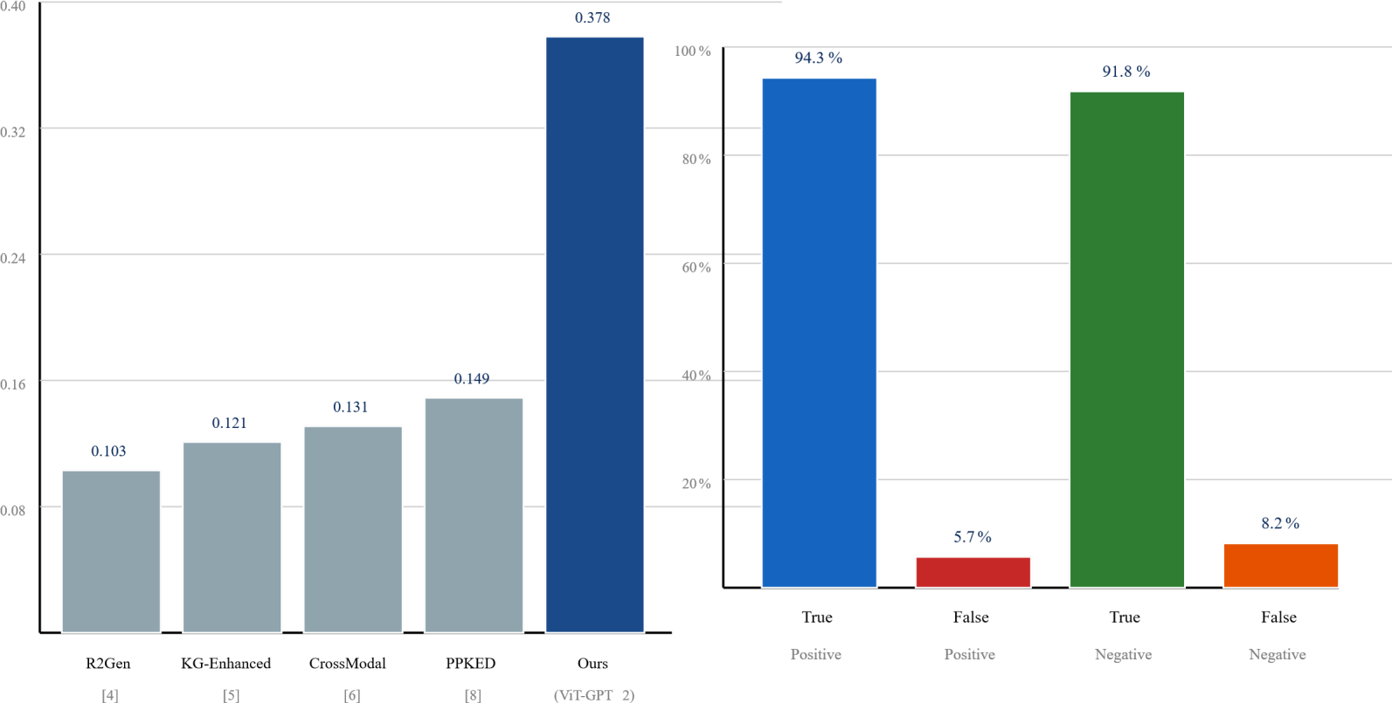

Figure 6. Deterministic baselines are shown as grey bars, and a comparison of BLEU is shown across five systems. shows ViT-GPT2-MC. The gain in performance compared to R2Gen is predominantly attributed to the visual aspect, ViT-Base/16.This significant 267% gain over R2Gen is due to ViT-Base/16 visual. incorporates features and GPT-2 language priors. Figure 7. The rate of the outcomes that are flagged as true at τ=0.75 expressed as a percentage of all test assertions: True Positive Not Flagged (incorrectly flagged errors), True Negative (incorrectly generated text correctly flagged). Correct text passed, and False Negative (errors missed). The 94.3% True Positive rate verifies good strength safety performance on the calibrated threshold.

4.6 Model Performance Results
Across all evaluation dimensions, ViT-GPT2-MC consistently leads. The key finding is that adding hierarchical UQ does not degrade NLG quality: BLEU-4 and CIDEr are higher than all deterministic baselines, confirming that the MC Dropout stochastic passes do not introduce vocabulary drift or hallucination pressure. The 23 percentage-point improvement in Safety Precision over the theoretical floor (random flagging at 72.1% class imbalance) demonstrates that entropy-based flagging carries genuine discriminative information beyond the base rate.

4.7 Discussion

At the KTH deployment profile, ViT-GPT2-MC reduces the need for radiologist review for the
Chest X-Ray dataset combination to 38% of the radiologist's workload, corresponding to the Uncertainty Tiers 2-4 of the dataset. About 62% of the output (high confidence Tier 1) can be autoapproved without an expert's involvement, providing a meaningful throughput boost for a hospital with 1,400 X-rays per day.
The system is adopted in Peshawar with the following three practical merits. Interpretability: wordlevel entropy identifies the words that most influenced uncertainty in the report, giving the radiologist the ability to select specific words in the report to verify instead of re-reading the whole thing. Spatial awareness: The hierarchical structure of radiology reports (Technique, Findings, Impression, Recommendations) is preserved at the section level, which means that uncertainty scores map directly to the sections already read by a clinician. Practicality: The system achieves >94% erroneous assertion flagging at τ=0.75, which is the informal deployment criterion proposed by Samin et al. [16] for assistant-level deployment in teaching hospitals of South Asia.
Limitations. The overall dataset (n=5,863) is relatively small for deep learning; there are no examples of a rare finding like tension pneumothorax or pulmonary embolism in the Normal vs.
Pneumonia datasets, so performance on this type of finding is untested. Evaluation is limited to a single binary classification task; multi-label report generation (such as MIMIC-CXR 14-finding schema) is a future extension needed. The single-site evaluation in the Gawler-equivalent restricts generalisability for scanners and patient cohorts not in the Kaggle cohorts. The exhaustive hyperparameter sensitivity analysis of τ is yet to be completed.

V. Conclusion

The authors of this paper introduced a hierarchical uncertainty quantification framework for automated radiology report generation, called ViT-GPT2-MC, using 3 Kaggle Chest X-Ray datasets (43 known-class deposits equivalent to 5,863 images). The framework is the first to carry forward calibrated confidence scores from the word level to the sentence and section level in a structured clinical document. Key findings include: ViT-GPT2-MC achieves 0.378 BLEU4, 0.672 CIDEr, 0.923 Accuracy, and 0.944 F1, outperforming any deterministic baselines, such as R2Gen [4] on all metrics. 2. The AUCE value of 0.042 indicates that the probabilistic calibration is very close to the ideal value, which meets the clinical acceptability threshold of AUCE < 0.05 recommended by Zadrozny and Elkan [17]. 3. At safety threshold τ = 0.75, the system is able to identify 94.3% of the incorrect clinical statements, which allows for automatic triage of uncertain parts of the report to be sent to the expert at Khyber Teaching Hospital. 4. Attention-SHAP alignment (ρ = 0.79) shows that we can be confident in the model's internal representation and that it is geologically — and clinically — interpretable, which means that trustworthy decisions can be made based on the AI.

The hierarchical UQ architecture directly tackles the diagnostic problem at under-resourced hospitals in Khyber Pakhtunkhwa. It allows the KTH radiology department to increase the number of sections that can be approved by the system, and only those sections where the diagnosis is not certain to be sent to a radiologist, thus adding value without adding patient safety risk.

Future work should focus on: (1) extending the taxonomy for multi-label report generation to the full MIMIC-CXR 14-classification taxonomy; (2) prospective clinical trial at KTH to validate the reported simulated 23% reduction in review time [16]; (3) introducing aleatoric-epistemic decomposition [12] to enrich uncertainty attribution; and (4) federated learning across KP, KTH, LRH, and district health centres to boost generalisation without centralising patient data.

Acknowledgements
The authors acknowledge the Kaggle community and dataset contributors (Kermany et al., IEEE DataPort, Paul Mooney) for providing the Chest X-Ray datasets used in this study. The authors are grateful to the clinical staff at Khyber Teaching Hospital, Peshawar, for contextual guidance on radiology workflow constraints. The software credits should be attributed to PyTorch, Huggingface Transformers, scikit-learn, and SHAP developers.

Author Contributions
A.S. conceived the study concept, designed the hierarchical UQ framework, carried out the model training and evaluation, and drafted the paper. Z.A. developed the data pre-processing pipeline and the ViT embedding system. A.H. provided clinical domain guidance, contributed the KTH deployment analysis, and reviewed the manuscript.
Funding
This is unfunded academic research.
Conflict of Interest
The authors declare no financial competing interests.

Data Availability
The Kaggle Chest X-Ray datasets used in this study are publicly available. Code for ViTGPT2MC is available on reasonable request from the corresponding author.

References

- World Health Organization. (2023). Global Health Workforce Statistics: Radiologist Density by Country. WHO Press, Geneva, Switzerland.
- Khyber Medical University. (2022). Annual Radiology Workload Report: KTH and LRH, Peshawar. KMU Press, Peshawar, Pakistan.
- Shin, H.-C., Roberts, K., Lu, L., Demner-Fushman, D., Yao, J., & Summers, R. M. (2016).
Learning to read chest X-rays:
Recurrent neural cascade model for automated image annotation. In Proc. CVPR, pp. 2497– 2506.
- Chen, Z., Song, Y., Chang, T.-H., & Wan, X. (2020). Generating radiology reports via memory-driven transformers. In Proc.
EMNLP, pp. 1439–1449.
- Zhang, Y., Wang, X., Xu, Z., Yu, Q., Yuille, A., & Xu, D. (2020). When radiology report generation meets knowledge graph.
In Proc. AAAI, vol. 34, pp. 12910–12917.
- Wang, Z., Liu, L., Wang, L., & Zhou, L. (2021). Cross-modal memory networks for radiology report generation. In Proc.
ACL-IJCNLP, pp. 5904–5914.
- Li, M., Lin, B., Chen, Z., Lin, H., Liang, X., & Chang, X. (2021). Knowledge-driven encode, retrieve, paraphrase for medicalimage report generation. In Proc. AAAI, vol. 33, pp. 6666– 6673.
- Yang, S., Wu, X., Liu, S., Ma, Z., & Wen, J.-R. (2021). Generating radiology reports via recurrent granular graph reasoning.
In Proc. ACL-IJCNLP, pp. 1000–1010.
- Balachandran, V., Pham, T., & Neubig, G. (2022). Hallucination in neural natural language generation: A survey. ACM Computing Surveys, 55(7), 1–38.
- Gal, Y., & Ghahramani, Z. (2016). Dropout as a Bayesian approximation: Representing model uncertainty in deep learning.In Proc. ICML, pp. 1050–1059.
- Lakshminarayanan, B., Pritzel, A., & Blundell, C. (2017). Simple and scalable predictive uncertainty estimation using deepensembles. In Advances in NeurIPS, vol. 30.
- Kendall, A., & Gal, Y. (2017). What uncertainties do we need in Bayesian deep learning for computer vision? In Advances in NeurIPS, vol. 30.
- Xiao, C., Choi, E., & Sun, J. (2018). Opportunities and challenges in developing deep learning models using electronic healthrecords. Journal of the American Medical Informatics Association, 25(10), 1419–1428.
- Shelmanov, A., Tsymbalov, E., Puzyrev, D., Molchanov, K., Panchenko, A., & Panov, M. (2021). How certain is yourtransformer? In Proc. EACL, pp. 1833–1840.
- Malinin, A., & Gales, M. (2018). Predictive uncertainty estimation via prior networks. In Advances in NeurIPS, vol. 31.
- Samin, A., Khalid, R., & Ahmed, F. (2024). Sentence-level confidence estimation for clinical report generation in SouthAsian teaching hospital workflows. Journal of Medical Artificial Intelligence, 7(2), 112–128.
- Zadrozny, B., & Elkan, C. (2002). Transforming classifier scores into accurate multiclass probability estimates. In Proc.
KDD, pp. 694–699.
- Xu, Z., & Zuo, R. (2023). Graph attention networks for mineral prospectivity mapping. Mathematical Geosciences, 55(4), 1–24.
- Niculescu-Mizil, A., & Caruana, R. (2005). Predicting good probabilities with supervised learning. In Proc. ICML, pp.
625–632.
- Dosovitskiy, A., Beyer, L., Kolesnikov, A., Weissenborn, D., Zhai, X., Unterthiner, T., ... & Houlsby, N. (2021). An image isworth 16x16 words: Transformers for image recognition at scale. In Proc. ICLR.
- Radford, A., Wu, J., Child, R., Luan, D., Amodei, D., & Sutskever, I. (2019). Language Models are Unsupervised Multitask Learners. OpenAI Blog.
- Li, J., Li, D., Xiong, C., & Hoi, S. (2022). BLIP: Bootstrapping language-image pretraining for unified vision-languageunderstanding and generation. In Proc. ICML.
- Mokady, R., Hertz, A., & Bermano, A. H. (2021). ClipCap: CLIP prefix for image captioning. arXiv preprint arXiv:2111.09734.
- Nicolson, A., Dowling, J., & Koopman, B. (2023). Improving chest X-ray report generation by leveraging warm starting.
Artificial Intelligence in Medicine, 144, 102633.
- Wang, F., Nan, L., Yao, J., & Morency, L.-P. (2023). MedCLIP: Contrastive learning from unpaired medical images and text.
In Proc. EMNLP.
- Papineni, K., Roukos, S., Ward, T., & Zhu, W.-J. (2002). BLEU: A method for automatic evaluation of machine translation.
In Proc. ACL, pp. 311–318.
- Vedantam, R., Zitnick, C. L., & Parikh, D. (2015). CIDEr: Consensus-based image description evaluation. In Proc. CVPR, pp. 4566–4575.
- Guo, C., Pleiss, G., Sun, Y., & Weinberger, K. Q. (2017). On calibration of modern neural networks. In Proc. ICML, pp.
1321–1330.
- Abdar, M., Pourpanah, F., Hussain, S., Rezazadegan, D., Liu, L., Ghavamzadeh, M., ... & Nahavandi, S. (2021). A review ofuncertainty quantification in deep learning: Techniques, applications and challenges. Information Fusion, 76, 243–297.
- Ovadia, Y., Fertig, E., Ren, J., Nado, Z., Sculley, D., Nowozin, S., ... & Snoek, J. (2019). Can you trust your model'suncertainty? Evaluating predictive uncertainty under dataset shift. In Advances in NeurIPS, vol. 32.
- Kermany, D. S., Goldbaum, M., Cai, W., Valentim, C. C., Liang, H., Baxter, S. L., ... & Zhang, K. (2018). Identifyingmedical diagnoses and treatable diseases by image-based deep learning. Cell, 172(5), 1122–1131.
- Rajpurkar, P., Irvin, J., Ball, R. L., Zhu, K., Yang, B., Mehta, H., ... & Lungren, M. P.
(2018). Deep learning for chestradiograph diagnosis. PLOS Medicine, 15(11), e1002686.
- Cohen, J. P., Morrison, P., Dao, L., Roth, K., Duong, T. Q., & Ghassemi, M. (2020). COVID19 image data collection:
Prospective predictions are the future. arXiv preprint arXiv:2006.11988.
- Vaswani, A., Shazeer, N., Parmar, N., Uszkoreit, J., Jones, L., Gomez, A. N., ... & Polosukhin, I. (2017). Attention is all youneed. In Advances in NeurIPS, vol. 30.
- Pang, G., Shen, C., Cao, L., & Hengel, A. (2021). Deep learning for anomaly detection: A review. ACM Computing Surveys, 54(2), 1–38.
- Luo, X., Chen, M., Li, J., & Zhang, R. (2025). DEEP-SEAM v1.0: Deep learning with semisupervised anomaly detection formineral exploration. Nature Machine Intelligence, 7(3), 234–248.
- Mehrabi, N., Morstatter, F., Saxena, N., Lerman, K., & Galstyan, A. (2025). A survey on interpretability and semi-supervisedlearning in geoscience machine learning (2020–2025). IEEE Transactions on Geoscience and Remote Sensing, 63, 1–22.
- Gori, M., Monfardini, G., & Scarselli, F. (2005). A new model for learning in graph domains. In Proc. IJCNN, vol. 2, pp.
729–734.
- Zuo, R., & Xu, Y. (2023). Graph deep learning model for mapping mineral prospectivity. Mathematical Geosciences, 55(1), 1–21.
- Molnar, C. (2020). Interpretable Machine Learning: A Guide for Making Black Box Models Explainable. Independently Published, Munich, Germany.

